Bridging the Water and Food Gap: The Role of the Water-Energy-Food Nexus
Rabi H. Mohtar^{1*}, Amjad T. Assi², Bassel T. Daher²

¹ Biological and Agricultural Engineering Department and Zachry Department of Civil Engineering, Texas A&M University, College Station, TX 77843-2117, USA, mohtar@tamu.edu, +1 765 4090309.
² Biological and Agricultural Engineering Department, Texas A&M University, College Station, TX 77843-2117, USA.

Abstract

The paper introduces global resources challenges and their risks and shifts in what society defines as global securities. The paper will then introduce the water – energy – food nexus as a resource integration platform and will highlight green water as a hotspot in this nexus. Analysis will focus on the manner in which green water should be viewed as a resource base for food security. Discussions related to its regional integration into food security issues will be explored and the implications of climate change, externalities that affect water resources variability, and changes to the green water will be discussed. Nexus hotspot applications are introduced to highlight the use of the nexus as a holistic platform to address water, energy, and food resources. The paper closes with the presentation of recommendations for next steps.

1. Introduction
Food and water security are among the top global risks facing the future of our planet and our way of life. Not surprisingly, four out of the top 10 global risks highlighted in the 2014 World Economic Forum report, The 2014 Global Risks Report, are directly related to water and food security. The report highlights a major shift in the risks and in the manner in which the global community views these risks. The big risks are seen as economic, environmental, and societal, rather than geopolitical, and this represents a major shift in the manner in which the global community sees future risks. The report touched on the enabling conditions for good resource management, i.e. governance and political and social instability. The report also highlighted the way in which global risks are interconnected and have large-scale impacts that ripple across economies and societies. Managing global risks effectively requires that we make the effort to understand, measure and foresee the evolution of the interdependencies between risks. Essentially, the report reaffirms previous calls for nexus thinking: looking not at each component in isolation, but rather, at the broader system of interactions of these components, and the refocus of our efforts into a new reality for managing their complexities.
Beginning with Bonn 2011, we will introduce the historical landmarks of the nexus scene and highlight the shift toward interdisciplinarity, understanding and identifying the role of this interconnectedness in decision making. At the same time, it must be emphasized that there is a need to create a holistic framework, one that considers the systems’ existent interlinkages and offers decision makers solid grounds for debate, discussion, and action. A few of these landmarks are highlighted here.
- Bonn conference (2011) focused on the interdependency of water, energy, and food security to be “explicitly identified in decision making”.
- WEF “Water Security” publication in 2011, representing a major benchmark in developing the conceptual framework of the nexus.
- Rio+20 highlighted the linkages between water, food security, nutrition and sustainable agriculture, sustainable cities, health, biodiversity, desertification, etc.
- COP18, Doha, UNFCCC Executive Secretary, described the food-water-energy nexus as the “human face” and solution to climate change (WMO, 2012). UN Secretary General highlighted the use of a nexus approach, urging the inclusion of environmental, social and economic dimensions (GIZ, 2012).
- WEF as global security issues (InterAction Council summit, Bahrain, May 2013).
- G-20 Clean Energy Ministries developing the WEF work stream. Korea, May 2014.

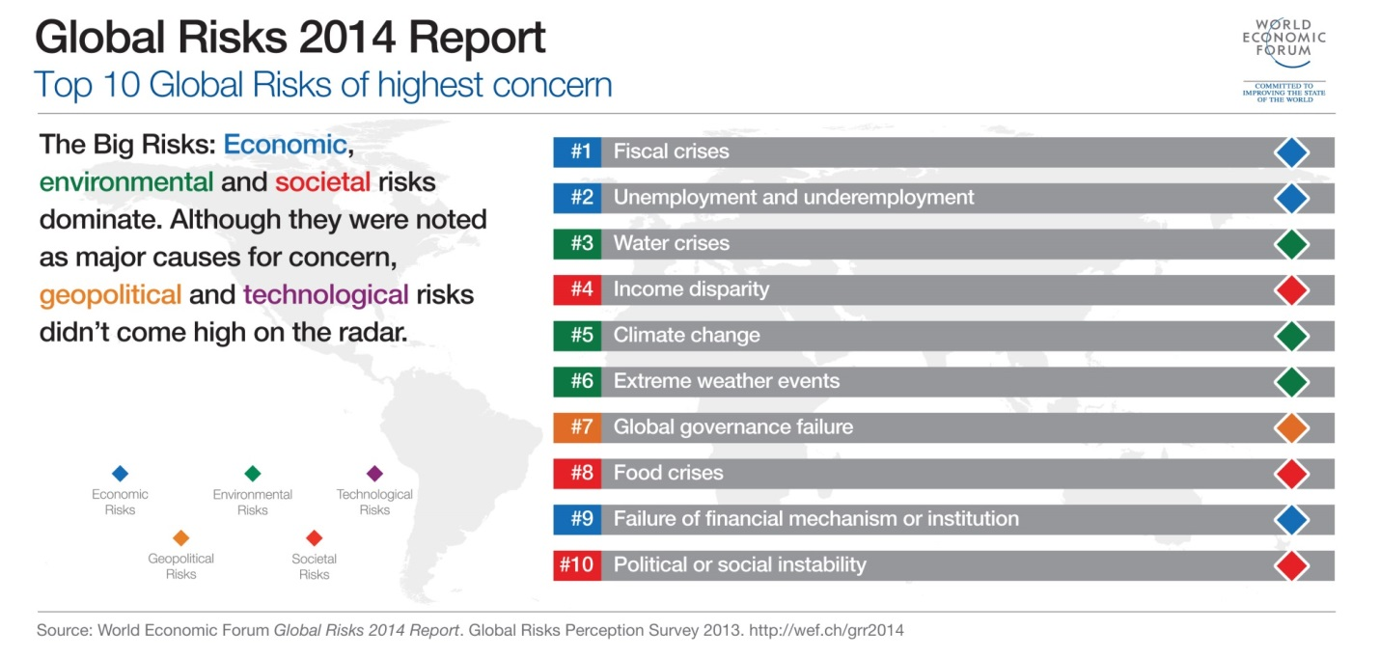
Figure 1.1. Top 10 global risks of highest concern, as reported in World Economic Forum Global Risks 2014 report
The change in the risks, from geopolitical to economic, were highlighted in other reports as well, including the InterAction council report (Axworthy and Adeel, 2014), which highlighted the Water Energy Food (WEF) nexus as a major risk for the human community, together with nuclear risks and those of terrorism. The consequences of climate change spatial variability on water and food supply are difficult to predict precisely, but, in general, the negative consequences will outweigh the positive (Godfray et al., 2010). A study of global projections based on different climate change scenarios and models, enforces the principle that wet regions will receive even more water and dry regions will become dryer; and that there will be ecological shifts due to rising temperatures, which will lead to increased risk for water and food security and their distribution (Figure 1.2). Dramatic changes are expected in the availability and spatial distribution of the renewable fresh water, both ‘blue water’ in rivers, lakes, and ground, and ‘green water’ in evapotranspiration and soil moisture. Blue and green water are collectively represented by river flows and soil moisture (Milly et al., 2008; IPCCa, 2013). Figure 1.2 shows a significant and positive correlation between river flows and soil moisture.
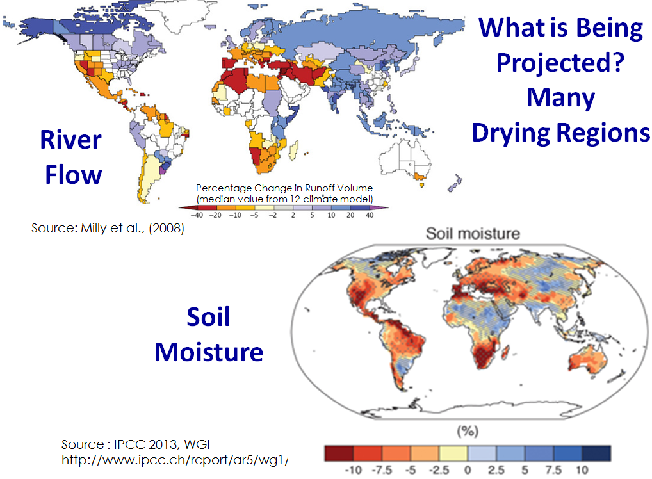
Figure 1.2. Projected climate change spatial variability of global shifts in river flows "blue water" and soil moisture "green water". The wet regions will get wetter and the dry regions will become dryer. (Milly et al., 2008; IPCCa, 2013)
The expected increase in drying regions is not the only manifestation in which climate change is shifting risks, as well as the potential for risk reduction through adaptation and mitigation. The temperature spatial and temporal pattern will change, and along with the change in rainfall pattern, the adaption plan for the water-food supply will become even more challenging. Moreover, projections include more heat, decreases in sub tropic intensification, longer periods between rain events, and drying of mid-continent in summer. All of these create increased risks of drought, increased hurricane intensities, increased wind events, an increase in the number and intensity of storms, and a rise in sea level (Table 1.1). As an example, consider the potential impact of 1.5 m sea level rise on Bangladesh (Figure 1.3): nearly 22,000 km² in coastal areas, 16% of the country's land area, will be flooded and hence no longer arable, 17 million inhabitants, or 15% of the population will be impacted (UNEP/GRID, 2006).
The implications of these risks can be summarized in increased plant water needs, greater urban demand, and less fresh water supply, especially in subtropics. There will be more pests, less grass, a general northerly crop migration, and changes in the eco-zones of crops. All of these projected risk are associated with diminishing water quality, increasing energy prices, and intensification of water-food insecurity in the most vulnerable countries in the world.
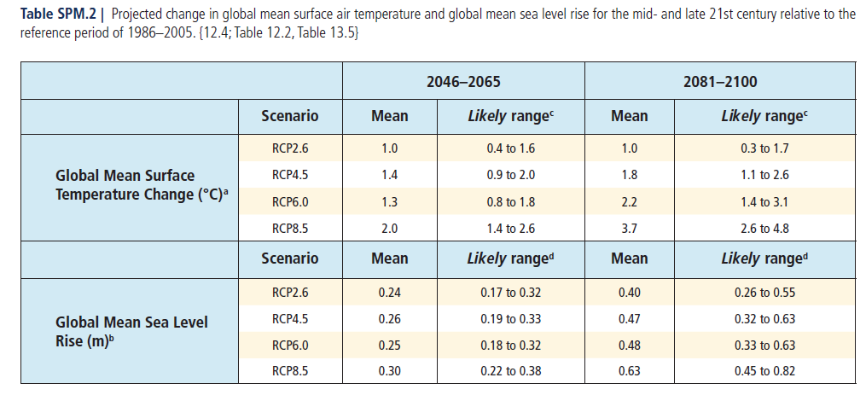
Table 1.1. Projected change in global mean surface air temperature and global mean sea level rise for the mid and late 21st century, relative to the reference period 1986-2005. (IPCC, 2013b)
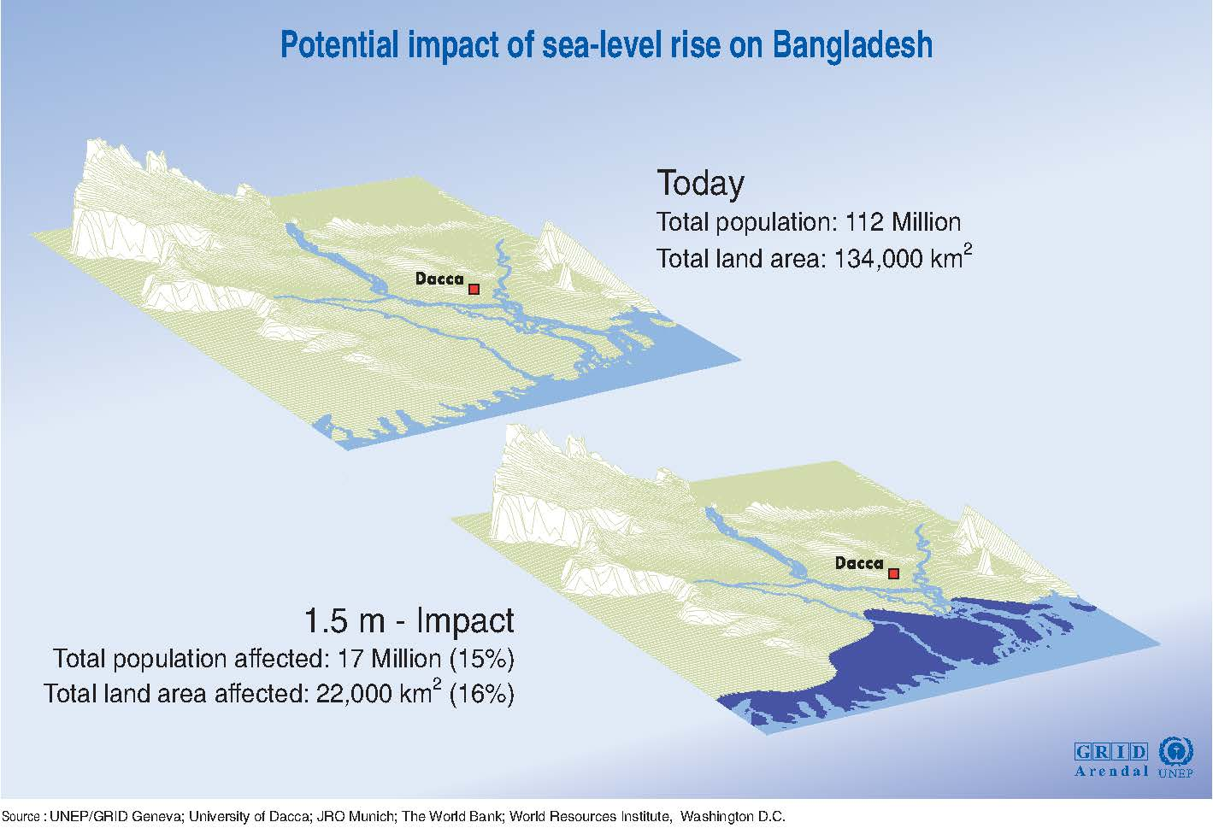
Fig. 1.3. The potential impact of 1.5 m sea-level rise on Bangladesh (UNEP/GRID, 2006)
The world also faces a shift in the global grand challenges due to internal dynamics (Figure 1.4). The population is expected to grow to 9 billion inhabitants by the middle of this century; the majority of this population will live in cities in developing countries. An additional 1669 billion cubic meter of water (40% new water) is needed, by 2030, to meet their water, food, energy and living demands (WEF, 2011). These inhabitants are expected to be wealthier and their purchasing power will enable a higher demand of processed food, meat, and dairy, further pressuring the food supply system (Godfray et al., 2010). At least a 50% increase in the food demand, and a 40% increase in energy demand is expected by 2030 (WEF, 2011). Such demands impose a challenging question about the adequacies of water, land, energy resources and infrastructures to meet the needs of the increased number of inhabitants. The question is not only about availability but also about equitable distribution and accessibility to these resources all over the world. For instance, the decrease in the precipitation in most sub-tropical regions is associated with less food production. In addition to these uncertainties and challenges, the most critical challenge, from the science and policy perspective, is that they are non-stationary: the past will no longer be a reliable predictor of the future, and this reality plays an important role in the ability to predict and plan for adequate water, food, energy infrastructures under uncertain and changing climate conditions (Milley et al., 2008). In the end, we must develop adaptation plans for water, food and energy supply systems. These plans must maximize resilience to the dynamic internal and external stresses that are occurring in our world.
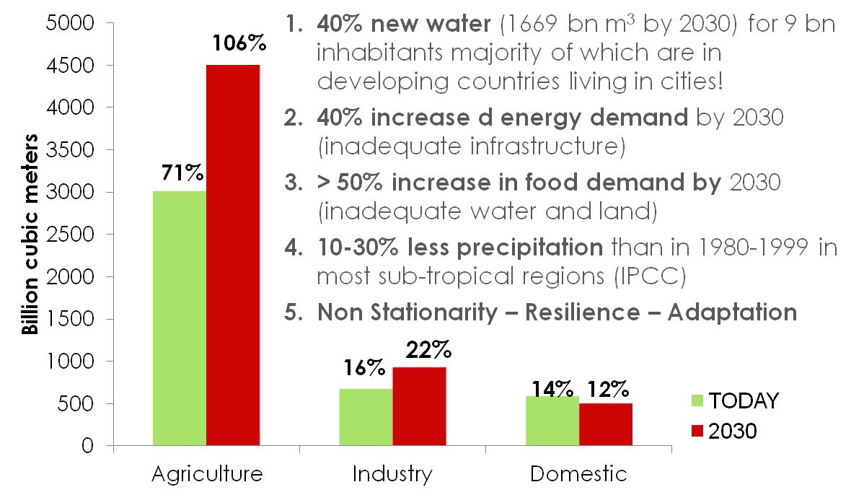
Figure 1.4. A summary for the global view of the grand challenges. (WEF, 2011)
The high demand on energy is a driving force to find more resources. Despite the good socio-economic implications, some of these resources add additional pressure on the quantity and quality of water resources. Fracking, for example, puts the United States first in shale gas production. Figure 1.5 below, shows a projection, from the U.S. perspective, of fracking and its potential contribution to gas production. However, this production imposes several environmental concerns or threats, including: water use in parched areas, creating waste water, triggering small earthquakes, contaminating groundwater, and reducing the demand for carbon-free renewable energy sources such as solar and wind, due to the low cost of natural gas.
The high interconnectivity of the water, food and energy supply-demand management requires a holistic, multi-scale, multi-stakeholder approach. It requires a Nexus platform to determine the interlinkages and tradeoffs for resources management and allocation and to look into hotspot interventions where nexus solutions can be entered.
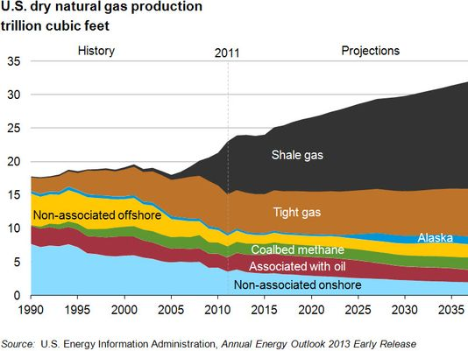
Figure 1.5. Projection from U.S. perspective of fracking and its potential contribution to gas production (EIA, 2013)

2. Situational Analysis of the Global Water-Food Demand and Supply Challenges
The biggest debate nowadays in tackling the water and food security is: whether the water-food crisis is due to the insufficiency of natural resources or due to a poor understanding and improper management of these resources. As discussed in the introduction, the answer for such a question is geographically dependent. For example, Godfray et al. (2010) concluded that "the world can produce more food and can ensure that it is used more efficiently and equitably". Still, 1-2 billion people are suffering from lack of access to sufficient dietary energy and/or micronutrients (Barrett, 2010). This means that more than 13% of the world’s population lacks access to food or are chronically malnourished (FAO, 2009a; Godfray et al., 2010, Keating et al., 2014). Similarly, Oki and Kanae (2006) showed that the current global water withdrawal is way below the upper limit of the global renewable fresh water. They questioned our concerns about water security, knowing that globally, we are using only 10% and 30% of the blue and green water resources, respectively. However, there are still more than 1 billion people who lack access to safe drinking water (Gleick, 2003), and at least twice that number live in water-stressed areas due to the uneven distribution of the water resources.
According to Barrett (2010), food security is based on three inherently hierarchical pillars: availability, accessibility, and utilization. The factors affecting each of these pillars varies across the globe. There is high variation in the availability of natural resources, water, land, and energy, even across regions of the same climate. This is in addition to the socio-economic, cultural, natural, financial, and political constraints that also affect access and utilization of these resources. All together, these factors form a major challenge to successfully addressing the water and food crisis. The availability of sufficient natural resources to produce food is vital for water-food security. However, in many cases it is not the only reason for the global water and food crisis. The main reason for the suffering of more than one seventh of the world’s population is access to food due to poverty and spikes in food prices (Foley et al., 2011; FAO, 2009b). It is expected that these spikes in food prices will become more frequent with the increase in competition for the natural resources, mainly due to the bio-fuel production but also due to climate change. Thus, with the projected food prices shown in Figure 2.1, new political and economic dimensions will be added to the poverty and social dimensions already mentioned as factors essential to the effective understanding of food crisis (Godfray, 2013). It should also be remembered that the two major historical food prices spikes were primarily due to the challenges of the energy issue. In the 1970s, the oil crisis caused a spike in global food prices, and one of the major reasons for 2008 spike was bio-fuels production.

Figure 2.1. Projected increases in the price of selected food categories between 2000 and 2050 with and without climate change. (Nelson et al., 2009)
The third pillar, utilization, is also important. It highlights the societal values, attitudes and awareness about conserving valuable resources. Actually, utilization is a measure of the good use of the water and food accessible to human beings. Figure 2.2 shows the water foot print for the food supply chain. Nearly 50% of the food produced in the USA is lost or wasted at home, and the situation in UK is not much different. While, the majority of the food loss in the developing countries occurs on the farm, in transportation, and in processes due to other technical and financial reasons. Utilization is another dimension that concerns the use of safe, nutritionally balanced and essential food. These dimensions shed light on the need to change agricultural consumption patterns: considered to be a strategic necessity for facing food security challenges.
Agricultural intensification is one of the proposed solutions for facing the projected need for a 60-100% increase in food production by 2050 (FAO, 2006; Foley et al., 2011; Alexandratos and Bruinsma, 2012) and to successfully meet the water-food crisis. The basis of this concept is to maximize food production still using the same amount of water and land. To be sustainable, the impact on environment must be minimized. This represents a major challenge for many reasons, among them: (1) the area of productive land is decreasing due to human factors such as urbanization, and human-climate change factors (desertification, salinization, and soil erosion); (2) even though it seems more reasonable to carry out land reclamation in order to increase the productive use of land in some parts of the world, humans need to be conscious about the nature of this land. For instance, converting forests and wet lands to productive, agricultural land will increase greenhouse gases, thus quickening climactic change; (3) the way in which food is produced also significantly impacts water resources, both their quality and their quantity. It further impacts the surrounding environment with respect to greenhouse emissions and biodiversity, as well as soil structure and health, both of which, in turn, affect the functionality of the productive land to continue to produce food in future.

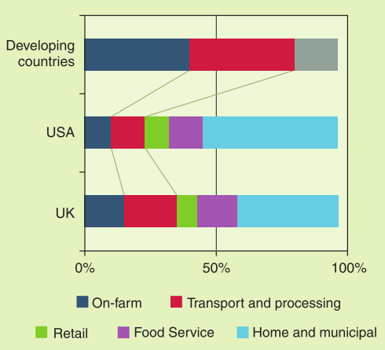
Figure 2.2. Makeup of total food waste in developed and developing countries. Retail, food services, and home and municipal categories are lumped together for developing countries (after Godfray et al., 2010)
Considering the constraints mentioned above, agricultural intensification is a two-fold challenge. The first is about bridging the yield gap through minimizing the difference between current productivity and best potential productivity (Godfray, 2010; Foley, 2011). The second is about increasing the efficiency of usage and thus, the productivity of the agriculture’s natural resources: soil, water, and energy. In both cases, there is a need for access to better varieties of crop species, sufficient nutrients, safe water-supply, improved technologies, and management frameworks that optimize and maximize the food production while minimizing its environmental side-effects. Foley et al. (2011) showed that bringing the yield for 16 staple crops (barley, cassava, ground nut, maize, millet, potato, oil palm, rapeseed, rice, rye, sorghum, soybean, sugar beet, sugarcane, sunflower and wheat) to 95% of their best potential production will increase their current supply to the world food market by 58% (2.3 billion tons ~ $5×{10}^{15}$ kilocalories). While the spatial variability of such improvement is very high, as shown in Figure 2.3, the ability to bridge the yield gap is exceedingly constrained by the availability of soil, water, and energy resources.

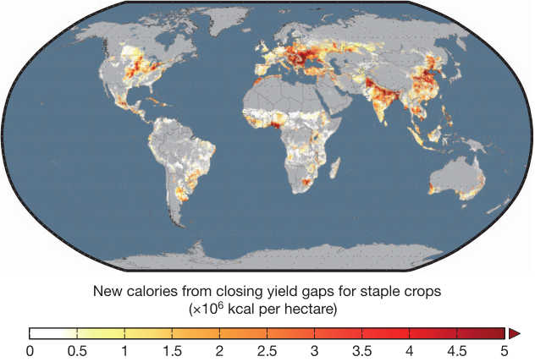

Figure 2.3. Spatial distribution of the potential new calories that can be added to the world food supply by bringing the world’s yields to within 95% of the best potential yield for staple crops. The distribution and availability of the natural resources of soil, water, and energy have a clear footprint on the ability to bridge the yield gap (Foley et al., 2011).

Global food supply can also be increased by reducing food waste and altering the diet. Globally, 30-50% of the food produced on the farm has never been consumed (Gustavsson et al., 2011; Lundqvist et al., 2008). As shown in Figure 2.2., the reasons behind such enormous losses vary and have a high relation to the type of countries, whether ‘developed’ or ‘developing’. Foley et al., (2011) studied the potential increase in food supply as a result of altering the diet to use the same 16 staple crops (Figure 2.4). The motivation behind such an idea is the fact that more than 75% of the world's agricultural land is used to feed animals, and about 35% of the total mass of global crop production is used to feed these animals. They found that shifting these 16 staple crops’ production to feed human beings, rather than animals, will add 1 billion ton (28% increase) to the food supply market. Such a shift is controversial and, in any case, very few countries are able to contribute toward such a shift (as shown in Figure 2.4).

It is obvious that there is no single general solution to the water and food crisis. The variation in the availability of natural resources, together with socio-economic, political and financial variability around the globe, make it more feasible to localize the water-food management system. Considering water utilization as a major global challenge, Gleick (2003) urged a soft path to localize the water supply system as a means of increasing the sustainability of these systems and the resilience of the communities depending upon those supplies. We agree with Gleick on the need to localize water-food supply systems and propose a new paradigm that enables quantification of the interaction and processes between the major natural components of climate, soil, and water: this paradigm will be discussed in section 3. At the same time, we suggest that the food-water system contains a third element and that the nexus of all three must be considered in a holistic approach that includes energy. We propose a framework to reduce the water-food crisis by localizing the food-water systems and globalizing the consequences through a water-food-energy nexus approach.

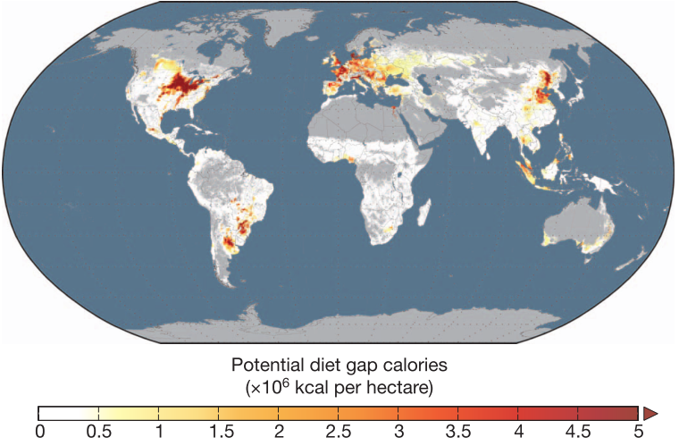

Fig. 2.4. Spatial distribution of the potential new calories that can be added to the world food supply by devoting 100% of the 16 staple crops for human consumption. The distribution and availability of the natural resources "soil, water, energy" has a clear footprint on the ability to contribute for such a shift (Foley et al, 2011).

3. The Systemic Approach Applied to Quantify the Water-Food Nexus
The most promising, sustainable solutions for addressing the water-food crisis rest upon the assumption that there will be no additional land allocated for agricultural production. Thus, limited land resources requires our most effective and efficient use of water resources, the best seed varieties, and a minimum impact on environment and on soil health. This section will address two of these assumptions: (1) the effective use of water resources, namely, quantification and accounting for green water, and (2) the understanding, quantification and proper management of the impact of human agro-environmental practices on soil structure: a major contributor to the soil health. Such a task requires a new paradigm to consider the natural organization of the soil medium, and to physically quantify its interaction with water and with the surrounding environment. As mentioned before, water and environment, climate, and climate change, play pivotal roles in food security.

3.1. Water-Food Nexus
The question remains: how do we bridge the water-food gap that exists today, as well as the projected increase in this gap in the coming 10-15 years? Without doubt, trade, investment, and virtual water have been and will continue to be, considered as a significant element of the water-food security portfolio (Fig. 3.1). Many countries in dry and semiarid regions of the world will be incapable of locally producing sufficient food to satisfy their own needs. Another necessary element of the portfolio will be conservation: improved crop genetics, improved efficiency and appropriate policies. All of these components must be included as part of the food and water security portfolio for these, and all nations. Nevertheless, this section will not highlight these important, and crucial elements but will focus on: better utilization of an underappreciated and ill-defined sources of water, namely (1) green water, generally defined as the portion of rainwater that is stored in the soil and used by plants for evapo-transpiration and consumptive use; and (2) NEW water (greywater, wastewater, and produced water from oil and gas operations), by quantifying and understanding the impact of such use on soil health, quality and productivity.
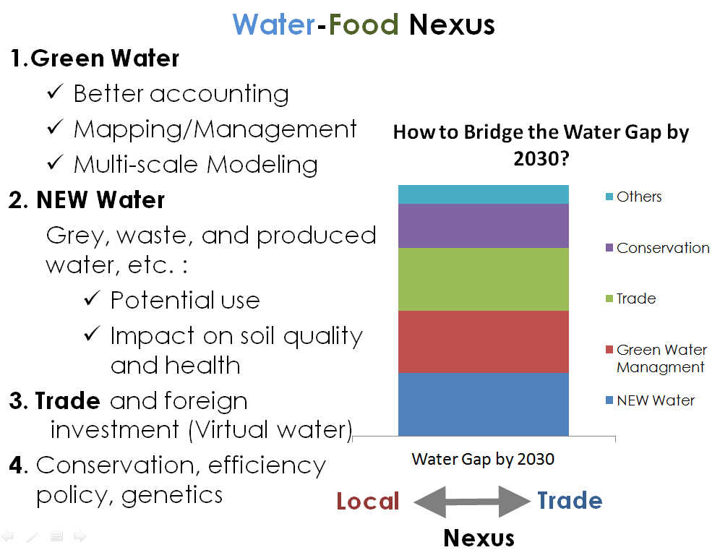
Figure 3.1. The nexus between local and trade and the question that scientists and policy makers alike will need to answer is: how much for a specific location or scenario. The gap can be meet with green water and the creation of water reuse scenarios that can satisfy parts of the gap.
Based on the above description, improved accounting mechanisms and a better definition of green water (GW) must be established. These accounting mechanisms will form the basis of geospatial mapping, allowing us to geospatially map green water resources, including regional integration of concepts for managing this resource. In defining these concepts, we must look at a larger scale of water use efficiency: that which goes beyond the farm gate and allows for a regional view of water use efficiency, and water and cropping allocation. Such mapping is not possible without scalable hydrological modeling that allows for the transfer of information from one scale to the other and across scales.
Similarly, NEW water (NW), consisting of grey, produced, brackish, and waste water, are resources that should constitute a significant part of bridging the water and food gap portfolio. However, three research and development gaps must be addressed for this to happen: (1) the need to establish the potential reuse of NEW water, in terms of quantification, proximity and use, and water quality regulations, (2) the need to establish the quantifiable impact of using these chemically enriched waters on soil quality and human health, and (3) an economic optimization of where and how technology for cleaning and remediating these NEW waters can be used, while keeping the end goal in mind in terms of the quality of the water and the cost of its use. Current waste water treatment methodologies are too costly and are not customized for specific effluent characteristics and the costs associated with selective treatment. For a long term, more resilient water and food security system, the use of these two water supply pillars, green and new (grey) waters (GW and NW), must first be optimized for a specific community. Only then will we be able to look into trade and virtual water solutions.

3.2. The Struggling of Green Water Concept
The sustainable use of the three pillars of the natural system, namely soil, water, and atmosphere, is key to addressing the water and food crisis of today and the future. However, managing these resources requires a quantifiable, physical characterization and modeling of the hydro-functioning of the soil-plant-atmosphere system. The lack of such a framework makes it difficult, if not impossible, for the scientific community to agree on a unified definition for green water. GW is that portion of rainwater naturally available for crop production, and most importantly, for the functioning of all biotic and abiotic processes taking place within the soil. The global soil moisture (GW) represents only 5% of the global fresh water; however, four very important facts greatly increase its value: (a) 60% of global food production is produced by GW (Cosgrove and Rijsberman, 2000), (b) 87% of the water used in global crop production in the year 2000, was GW (Liu and Yang, 2010), (c) 58% of the world cereal production is cultivated in areas that use only GW, and (d) we utilize only 30% of the renewable green water globally. In their study of modeling blue and green water availability in Africa (Schuol et al., 2008), and as shown in Figure 3.2, Schuol et al concluded that there is double green water storage in the soil water profile as blue water availability in Algeria and Morocco. Even though the numbers in Figure 3.2 are preliminary and require additional precision in terms of accounting of the various water pools, these numbers substantiate the fact that, by itself, GW is a resource that must be better utilized and that while most dryland regions focus on blue water resources, special focus on green water is a worthwhile and perhaps, more productive effort.
The concept of green water was first introduced by Falkenmark (1995) as a potential option for increasing agricultural production. He defined green water as the fraction of rainfall that infiltrates into the root zone and is used for biomass production or evapotranspiration. Actually, not all the water that infiltrates into the root zone stays there. Part of it percolates or flows to groundwater and rivers, becoming blue water. Later (Rockström, 1999) redefined green water by considering evaporation from surface and intercepted water as a non-productive fraction of green water! This definition brought additional confusion regarding the identity of GW by considering evaporation as green water. Finally, both Falkenmark and Rockström (2006) concluded that GW consists of two parts: (a) green water resource (storage) which equals the soil moisture; and (b) green water flow, which equals the sum of the actual evaporation and actual transpiration. However, Gerten et al. (2005) had a different definition of GW: it is the precipitation water stored in the soil and eventually transpired by natural and agricultural vegetation. Gerten, thus excludes the accounting of evaporation in GW, thereby contradicting the Falkenmark and Rockström (2006) definition.
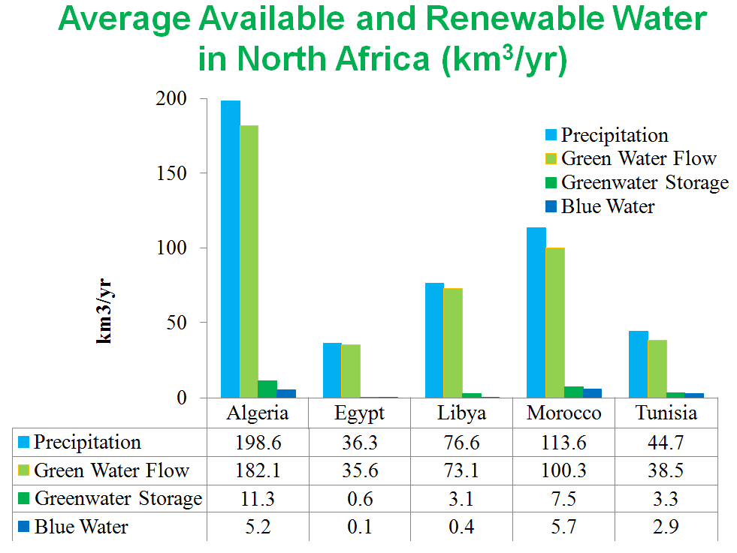
Figure 3.2. The green and blue water portions from the total precipitation (Schuol et al., 2008)

3.3. Pedostructure -SREV Concept: A Quantification Tool of Soil-Water-Atmosphere Interactions
After demonstrating the confusion surrounding the definition of green water as an important resource that must be better utilized, we now look at how we can accomplish this improved utilization. To address the limited understanding of GW processes, three research gaps will be explored, as follows.
Gap 1: The lack of recognition and characterization of soil as the organized physical medium, providing the physical conditions for life and development of the numerous biotic and abiotic processes inside the soil medium.
We will show here that we must adopt a new paradigm for characterizing and modeling the physics of the water cycle in the soil and the interaction of water with the natural environmental medium consisting of soil and air. Only then, we will be able to quantify and manage the green water. To model these natural interactions, we distinguish between what is called ‘free’ or ‘blue’ water, whose principle driving force is gravity, and what we will now refer to as ‘thermodynamic water’ or green water, which is linked in dynamic equilibrium with other basic components of the local environment: namely solid particles and air or atmosphere. Actually, in contrast to blue water, which is well known and modeled by hydrologists, the thermodynamic aspect of water is poorly known, especially within the soil medium. The problem is that the water in soil is mainly thermodynamic but cannot be neglected due to its direct link to the climatic conditions for life in the soil and in the air above the soil.
The soil medium is differentiated into horizontal layers, called soil horizons. These soil horizons have different structures, each of which is characterized by its own hydro-structural properties. These horizons and their characteristic structures (pedostructure) result from the pedo-climate regime which is the direct product of both water cycles: the blue water cycle, starting with rainfall on the soil surface and going down or laterally through gravity, and the green or thermodynamic water cycle, which is linked to the medium and goes up through the soil-plant-atmosphere continuum. See Figure 3.3.
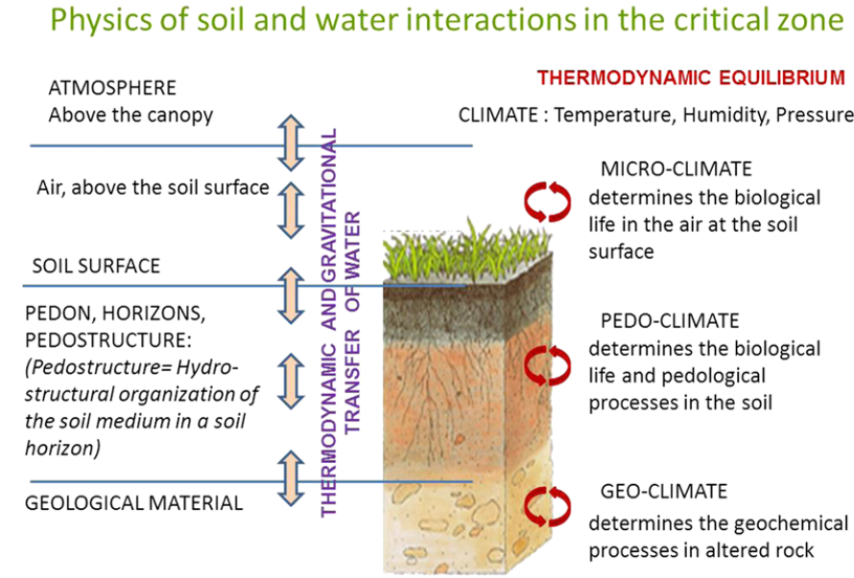
Figure 3.3 Modeling the soil-plant-atmosphere as an organized system in thermodynamic equilibrium dependent upon the local water content (after Braudeau and Mohtar, 2014).
Today, the problem lies in characterizing the organization of the soil medium and its functionality with water, as illustrated in Figure 3.4. Both graphs represent the three axes of description for any organized object, in this case the soil. Axis 1 represents the evolution of soil over time, axis 2 represents the nature and morphology of soil (soil genesis and organization, or pedostructure). Together, axis 1 and 2 represent the solid plane, where the soil properties are a function of the morphology and evolution as these are impacted by soil management. This plane offers substantial descriptive or qualitative information that is used to prepare the helpful soil maps available today. The third axis represents the hydraulic functionality of this soil-water system. The difference between Figures 3.4 (a) and (b) lies in the connectivity or linkage with this fundamental plane. Existing soil-water modeling, as shown in Figure 3.4(a), uses the widespread concept of the Representative Elementary Volume (REV) principle. The REV concept overlooks or ignores the soil structure. Assuming the soil medium to be a mixture of solids, liquids, and gases, and that the base volume changes dynamically with the swelling and shrinkage properties of a given soil, this representation leads to a disconnect between the hydro-functional axis and the other two axes, which describe the morphology and evolution of the multi-scaled soil organization. Thus, there is a need to move away from the disconnected models and toward a model connected with soil structure.
This connection was identified by Braudeau and Mohtar (2009) and defines a new paradigm in soil science – the hydrostructural pedology. It is based on the pedostructure concept (the soil medium organization as an assembly of primary aggregates) and the Structure Representative Elementary Volume (SREV) concept. Pedostructure defines two types of thermodynamic water in the soil medium organization: micro-poral water or the internal water of primary peds, and macro-poral water or that which is external to primary peds within the pedostructure. At equilibrium state, water potential is equal in both poral spaces. The SREV concept governs the discretization of the soil medium and allows for the transformation of the soil medium organization into closed thermodynamic systems that are closed on the solid particles of the structure (Figure 3.4(b)).
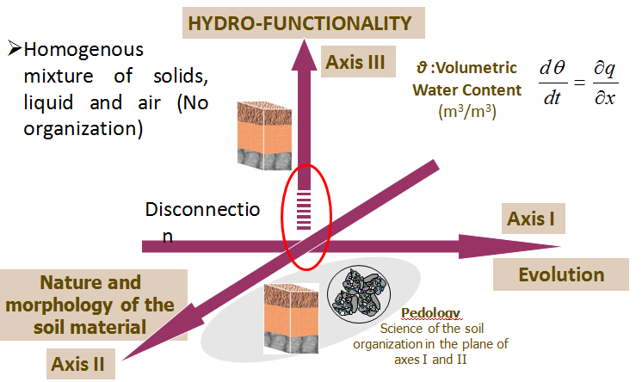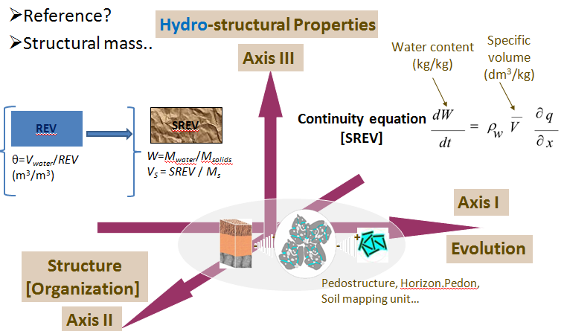Figure 3.4 Modeling the soil-water system within the soil-plant-atmosphere continuum. Overcoming the disconnect with the soil structure by shifting the paradigm from the Representative Elementary Volume Concept (REV Concept) (a) into the Structural Representative Elementary Volume Concept (Pedostructure-SREV Concept (b).
(a)
(b)
In the new paradigm, one can physically differentiate and quantify two water cycles in the natural environment, the blue water cycle and the green water cycle ( referred to here as a thermodynamic water cycle) within the pedostructure. This will eliminate a lot of confusion about the definition and quantification of green water as a valuable source for the functionality of the soil-water system and provide the pedo-climate for the occurrence of biotic and abiotic processes vital for food security (Braudeau and Mohtar, 2013).
Gap 2: Quantification of the soil natural organization or structure with measurable (physical) parameters that describe the interactions within the soil-water system.
One of the most challenging issues for the soil water research community is to quantify and characterize the impact of agro-environmental practices on the soil organizational structure, which is of course, a good indicator of soil health. Soil structure evolves over time and human intervention can affect its evolution and thus, its hydraulic functionality. Using the pedostructure-SREV concept and with the continuous measurement of three state variables of the soil-water system, namely soil water content, the corresponding volume, and the potential of this soil-water system, Assi et al, (2014) was able to identify a set of measurable parameters, each of which identify a specific physical characteristic within the measured soil-water medium (Figure 3.5). The implication of such a characterization is the ability to quantify soil structure and its evolution over time. This externality could be presented by changes in soil management (tilling practices) as well as by the use of chemically enriched water for irrigation. These are now much more critical than in the past: dwindling water resources will cause the community to look at alternative resources to satisfy their demand. The limitation has always been our lack of understanding the long term impact of these factors on soil quality. This paradigm means that soil quality can be quantified as well as the long term impact of the externalities.
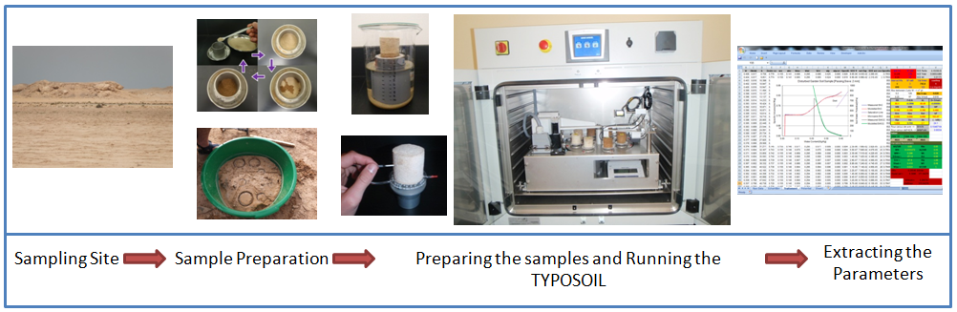
Figure 3.5 Extracting the hydro-structural parameters, where each parameter quantifies a specific physical characteristic of the soil-water medium.
Gap 3: The Natural Multi-scale Organization
The third gap is related to scaling and the transfer of knowledge across scales, whether from policy to practice or from practice to larger scale. Because of the current challenges in the modeling paradigm discussed above, current modeling frameworks are incapable of translating from larger or smaller scale to the opposite. Delineation of hydro-structural mapping units must be established using the existing soil units as basis. These soil units still lack quantifiable elements for their characterization. The characterization protocol mentioned above can enhance the qualities of these maps by augmenting with data such as hydrostructural parameters. Once updated with quantitative attributes, they can and should be used as basis for mapping data rather than guessing. With such a protocol, verified with soil samples and extracted relevant hydrostructural parameters using continuous and simultaneous measurements of soil shrinkage/swelling curves and water potential, these maps or models can be scaled to allow the transfer of information across the scale.
In this section, we highlight the major gaps that limit our vital exploitation of maximizing the use of underutilized water resources, whether due to the lack of a framework to quantify its availability and map its spatial distribution, as in the case of green (thermodynamic) water; or to the lack of a reliable tool to quantify its impact on soil health and productivity, as in the case of NEW water. With such an integrated framework, we will not only save water, but will also be able to observe and quantitatively evaluate the degradation of our limited productive land, both of which are vital for reduction of the risks posed to water-food securities.

4. Water-Energy-Food Nexus Approach
Section 3.1 highlights the importance of better accounting of water sources and the need for a deeper understanding of the potentials of each source. Such understanding and accounting will enable better utilization of locally available resources and contribute to bridging the food gap locally. At the same time, this will ensure an increased level of resilience, bringing with it a combination of robust trade strategies and foreign investment, conservation, and increased efficiencies. However, food production is not the only consumer of water. Second only to agriculture, energy production consumes 15% of global freshwater withdrawals annually (IEA, 2012). Moreover, even with expected changes in the global energy mix, the quantity of water withdrawn and consumed by the energy sector is expected to rise.
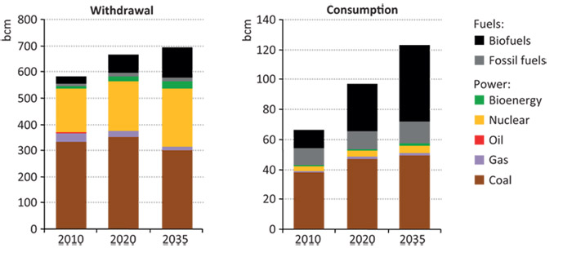
Figure 4.1: Global water use for energy production by fuel and power generation type for different future policy scenarios (World Energy Outlook-2012)
Water, energy, and food are highly interconnected. In order to assess the local-trade nexus presented earlier, a holistic, system-level platform for resource nexus solution assessment is necessary. Such a platform will help identify and quantify the interlinkages between water, energy, and food systems. Moreover, it will provide quantifiable trade-offs for various solutions and ensure that a given solution that meets the goals of a single pillar does not infringe on the other two pillars. Further, it will enable consideration and evaluation of informed ‘hotspot interventions’ where appropriate nexus solutions can be adopted. These quantifications, analyses, and evaluations constitute ‘nexus analytics’.
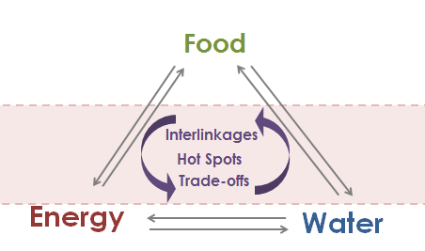
Figure 4.2: Water-Energy-Food Nexus Analytics
The relevant analyses are often lead by the scientific community, creating space and informed guidelines for policy, technological, and stakeholder dialogues. The dialogues must be based on inclusion of all sectors of the economy: governance, academia, civil society, private sector; and they should enable and induce changes in attitude, practices, and behavior that are based on knowledge. Such knowledge based dialogue can and will change the dynamic of conflict into one of cooperation by highlighting the need for and understanding of the trade-offs involved. The elements of the nexus platform must include an integrative view of water, food, and energy resource management; a view that needs to prevail at all levels. Last but not least, we must better engage the private sector and exploit its role in supply chain management through mobilization of resources, promotion of conservative, responsible investment, and R&D for enhanced business opportunities and the development of appropriate technologies.

4.1. Water-Food-Energy Nexus Tool: A Platform for Trade-off Analysis
In an effort to facilitate the nexus analytics, our Nexus Research group developed the WEF Nexus Tool, which provides a platform for scenario development and trade-off analyses. The tool captures inputs from both technical and scientific circles, as well as incorporates inputs from decision making circles. It reflects specific strategies, costs and trade-offs. The tool enables the development of scenarios by defining the food, water and energy, and trade portfolios of a chosen area. The WEF Nexus Tool output provides more than mere financial costs for a given scenario. It quantifies the elements of the scenario and includes:
- Water requirements
- Local energy requirements
- Local carbon emissions
- Land requirements
- Financial requirements
- Energy consumption through import
- Carbon emissions through import

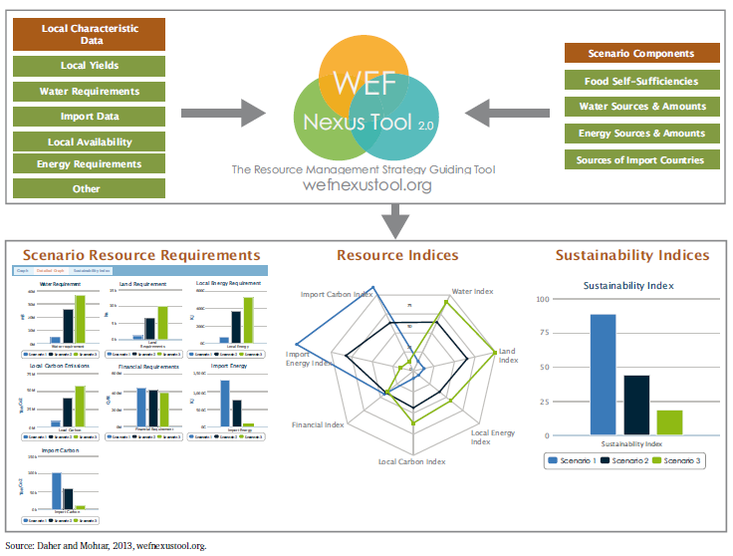
Figure 4.3 WEF Nexus Tool Structure (Mohtar and Daher, 2014)
The user is able to calculate and visualize the amount of resources consumed by different proposed scenarios. The user is then able to make an informed decision regarding the relative importance of reducing each of the ‘costs’ (water, local energy, local carbon, land, financial, imported energy and imported carbon), on a scale of 0-1 (0 for a cost that is least important to reduce, and 1 for a cost that is most important to reduce). Based on the relative importance of reducing any of these costs or resource requirements, the tool user is able to calculate the sustainability index for each scenario and then decide on the most favorable for adoption.
The underlying framework representing the quantitative relations and interconnections among the three systems, water, energy, and food, is generic. In order to create a scenario using the tool, site specific data such as local yields, rainfall, water resource availability, etc., must be identified. The tool’s framework is under continuous development and can be used to answer specific questions for various applications and across different eco-zones and scales.

4.2. Hotspots and Nexus Applications
Following the introduction of nexus analytics and the WEF Nexus Tool above, this section will explore case studies that represent different hotspots and reflect several critical questions to be addressed while making use of the nexus interlinkages and trade-offs.

4.2.1. Qatar Food Security
Qatar currently enjoys a period of growth and development catalyzed by an abundance of oil and gas resources. Yet, Qatar also faces severe challenges of water scarcity, aridity, and harsh environmental conditions: Qatar imports more than 90% of the food it consumes. While there are risks associated with such high reliance on food imports to supply the local market, a decision to increase local production requires a comprehensive understanding of the interconnected water-food-energy systems and of the trade-offs between them. Integrative planning is essential to ensure sustainable growth and eliminate unintended, negative consequences. Qatar aims to meet 40% of its food demand with local supply in the coming decade (Gulf Times, 2014). Achieving this goal will require the use of major resources, including water, energy, land, and financial. We conducted a sensitivity analysis for these resources, and concluded that the land requirement is the one most sensitive to increases in food production (Daher and Mohtar, 2014), and this is primarily the result of low local yield due to environmental conditions that are hostile to efficient agriculture production: land would be a major bottleneck for food production. While this could be partially bridged with technology, doing so comes at a high cost: Qatar receives an average of 80mm/year of rainfall and water withdrawals were recorded at 455% of actual, total renewable water resources in 2005 (Aquastat, 2014), therefore, tapping the ground water to execute the food security plan is not an option.
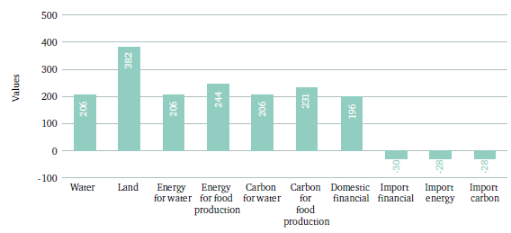
Figure 4.4 Percentage change in resource needs for a 25 per cent increase in the self-sufficiency of eight food products (Mohtar R.H. & Daher B., 2014)
Part of the Qatar’s food security plan involves the use of solar-desalination to provide water for agriculture. A preliminary assessment conducted by Daher and Mohtar using the WEF Nexus Tool, showed the need for 206% more water to enable an increment of 25% in food self-sufficiency for eight selected food products (Mohtar R.H. and Daher B., 2014). Even though solar desalination is considered to be the way forward in providing the needed water, aggressive infrastructural investments would be needed to increase current desalination capacities to achieve the set goal of food production. Alternatively, “new” water, or unconventional water (Treated Water), which is treated to the tertiary level, and sometime to quaternary level, is a valuable resource that should not be overlooked. Table 4.1 shows the energy required to deliver one cubic meter of clean water, using different sources of water (Cramwinckel, J. F., 2011). This water is a valuable resource and comes at a lower cost, when compared to more expensive desalinated water. It would contribute to bridging the water gap, while minimizing costs and reducing the need for infrastructural upgrade in terms of desalination capacity.
Source | Energy required (kW-h/m³)
Lake or River | 0.37
Groundwater | 0.48
Wastewater Treatment | 1-2.50
Wastewater Reuse | 0.62-0.87
Seawater | 2.58-8.50
Table 4.1. Energy required to deliver 1m³ of clean water from different sources.

4.2.2. Texas Water Scarcity and Implications
According to the Texas Water Plan of 2012, the state expects a 40% water gap and a supply demand deficit of 8.24 billion m³ by the year 2060. It is planned that 60% of the gap will be covered by conventional water sources, 24% from conservation, and 16% from non-conventional water supply - reuse and desalination (Arroyo, 2011). Arroyyo also expected 2.24 billion m³ of water would be needed to generate electricity in 2060.
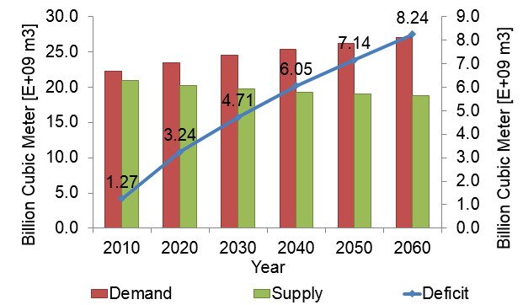
Figure 4.5 Projected water deficit in Texas (Texas Water Development Board, 2012)
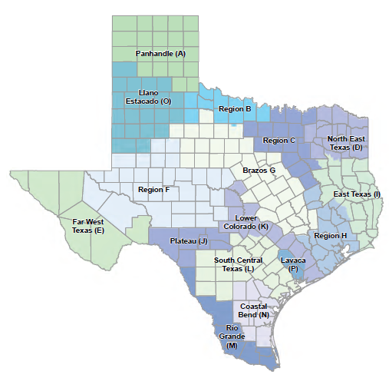
Figure 4.6 Regional Water Planning Areas (Texas Water Development Board, 2012)
How will this gap be bridged throughout the state? Due to high variability in ecology, climate, population, and the types of activities in different regions of the state, the plan divides the state into 16 regional water planning zones. The report notes that each zone is characterized by distinct populations, water demands and existing water supplies. Even though the expected water gap is statewide, it will affect the various areas differently. The way to bridge that gap will also vary with the region and depend upon resource availability versus need, and the type of water consumption activities happening in each region. Returning to Arroyo’s prediction of 60% of the gap being covered by conventional water, we introduce the following questions: can we do more; can we better utilize green water to reduce stresses; how could we better use New water in energy and agriculture; what would work where? Even though the problem is the same, solutions will need to be different for each specific scenario: giving rise to the need for a holistic assessment with localized solutions.

4.2.3. Water-Fracking-Transport Nexus
Fracking has expanded rapidly across the United States, with more than 82,000 new wells reported between 2005 and 2013 (Environment America, 2013). The fracking industry has brought a higher level of energy security at the national level as well as economic benefits to individual states and local communities. In Texas, more than 4,890 drilling permits were issued in the last 5 years in the Eagle Ford Shale formation alone (Rail Road Commission of Texas, 2014), causing energy production from shale to greatly increase.
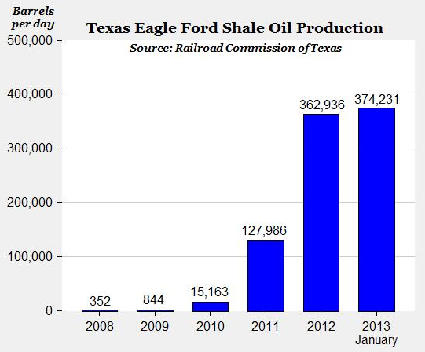
Fig. 7: Texas Eagle Ford Shale Oil Production from 2008-2013 (Green, 2013)
Fracking, as an industry, is not independent from other resource systems, nor is it isolated from surrounding local communities and their environment. Therefore, there is a need to understand the interlinkages fracking has with these different, yet interconnected, systems. There is also a need to quantify the impact that each of these systems has on the others so that, as fracking activity expands, unintended negative consequences are minimized. Three primary interlinkages will be explored in this framework.
Fracking-Transport interlinkages: Transport is an important element present at multiple stages in the lifetime of a fracking site. Whether at site set-up stage, drilling stage, or production phase, trucks are needed. Transport of produced oil and gas, solid waste, and other operational activities, requires the movement of trucks from site to delivery or disposal locations. With the growing number of fracking sites, and ultimately the number of trucks required to service them, road infrastructure deteriorates at a faster rate. This also impacts the level of service of roads due to congestion. A better understanding of the relation of increased fracking activity to transportation is crucial to determining future plans for road rehabilitation and expansion. It will also help determine better circulation patterns for trucks, in order to minimize negative consequences on existing and projected traffic.
Fracking-Water interlinkages: Fracking is a thirsty source of energy. Water is required for all phases of the process. Depending on the technology used, different amounts and qualities of water are required. Water could be pumped onsite or transported from a different location. It is important to understand relation between the amount of water required for fracking and the trade-offs associated with allocating more water to this industry as opposed to other, competing businesses, industries, or sectors in the area of interest. Fracking produces large quantities of contaminated water which must be treated and then properly disposed of. Depending on the level of treatment, choice of disposal site and technology, different resource requirements and risks must be accounted for.
Transport-Water interlinkages: The water required to complete the various stages of fracking can be transported through pipelines from neighboring sources, pumped onsite from existing aquifers, or transported by trucks onto the site. It is important to understand the water required and its sources for a given site, likewise, it is important to study the number of trucks that would be introduced to the roads, thereby causing congestion and infrastructure deterioration. Produced water is also transported out of the fracking site for treatment or disposal. Truck volumes must be considered in order to correctly capture and assess their effect on the road infrastructure.
The whole nexus between the three systems is effected by multiple factors, each plays a role in affecting the relations between them. These factors include economy, technology, policy, environment, and community engagement. For this application, it is imperative to use a nexus holistic platform to quantify and assess different growth scenarios associated with specific trade-offs, and then to adopt a holistic approach that looks primarily at the interrelations within the transport and infrastructural system. Those scenarios will be assessed by a list of identified economic, social, and environmental indicators.

4.2.4. US-China Agricultural Trade

The Food and Agriculture Organisation of the United Nations (FAO) estimates that, to achieve global food security, 70% more crop production will be required by 2050 (FAO, 2013). Much of this future demand will come from Asia, where the future economic centres are located. While this is often described as a driver of future food demand, very few studies analyse the impacts that future demand for food commodities will have.
China is projected to be the most likely environmental and economic hotspot of the twenty-first century. China will not be able to feed itself with the water resources directly available to it. Without external inputs, water will be the limiting factor in achieving economic growth and providing the emerging affluent middle classes with food products sufficient to meet increased demands (USDA, 2014). This is already understood in policy circles in Asia, and the United States.
China’s heavy dependence on limited, water-thirsty, fossil and renewable fuels will limit significant expansion of domestic food production. As a result, the government has begun to invest in agricultural trading houses to access food from other parts of the world. US decision makers from the public and private sectors view US-Chinese ag-trade as a pivotal strategic issue in global trade. The private sector has understood these new circumstances. For example, Bunge has invested 300m USD to build the first export food commodity terminal in over 25 years in Longview, Washington. It will serve Asian markets more efficiently and rapidly. At the same time, EU trade with China is growing in similar numbers (Bunge, 2014). In addition, China has begun to actively externalize environmental costs as a result of recognising the increasing competition between water, energy and food in China. There are also serious concerns about water quality.
One of the most bullish supply chains is the dairy supply chain. Over the past 15 years, China has become the largest diary importer worldwide, with China’s diary imports increasing by approximately 10 per cent annually since 2000 and expected to grow further in the coming years (USDA, 2014). While this will allow the US to benefit economically from increased trade, it will also add further pressures on water, energy and food systems, parts of which will be increasingly affected by climate change, for example the South-Western and Western regions of the United States that produce not only dairy but also animal feed.
A proposed approach to this nexus will evaluate the extent to which existing market governance is fit for purpose by mapping and modelling the future resilience of the US food systems with respect to the availability of water, energy and food resources in the wake of increasing demand from China. The study will fill a gap in understanding the environmental consequences of increased trade between US and China.
The framework should aim to quantify the use of water and energy at the state level using state data on dairy production to provide a natural resources perspective on resources use in dairy. In addition, data on dairy exports will be incorporated in the analysis to provide an understanding of questions such as: how much water and energy is exported in dairy to China; to what extent is the US dairy system sufficiently resilient to sustain future trade growth with China; how will increased agricultural production for export affect interconnected water and energy systems?

5. Conclusions and Recommendations
We have explored the grand challenges surrounding resource scarcity and the need for a holistic platform to quantify these interlinkages and analysis tradeoffs. We introduced a platform that can help with analysis of scenarios and provided examples of hotspots where nexus holistic thinking can be applied. In conclusion to this paper, four points need to be made:
1) There is a need for a holistic platform to determine interlinkages and tradeoffs for resource management and allocation. Such a platform will offer a systems view of the solution for each of the pillars, without infringing on the other pillars.
2) There need is a need for site specific accounting to determine the feasibility of alternative water for bridging the water food gap. Such feasibility must be accompanied by long term impact studies on soil quality and human health.
3) Green water is a precious resource that must be better defined, accounted for and represented in thermodynamic modeling and hydrologic scaling. Such a multi-scale hydrologic platform will enable quantification and mapping for managing system resources at a regional scale, where local information of the soil thermodynamics can easily be scaled up to the policy level and vice versa.
4) There needs to be a change in the understanding and characterization of the soil water medium such that soil and soil properties represent soil behavior.
Acknowledgments
The authors wishes to thank Ms. Mary Schweitzer for her through editing of this paper.

6. References
Arroyo, J., 2011, Updates on TWDB’s Innovative Water Technology Programs. http://www.twdb.texas.gov/innovativewater/doc/20110405_Updates_IWT_Program.pdf
Assi, A.T., J. Accola, G. Hovhannissian, R.H. Mohtar and E. Braudeau (2014). Physics of soil medium organization, Part 2: pedostructure characterization through measurement and modeling the soil moisture characteristic curves, Front. Environ. Sci., 2:5. doi: 10.3389/fenvs.2014.00005.
Aquastat (2014). Qatar. Retrieved from: http://www.fao.org/nr/water/aquastat/countries_regions/qat/index.stm
Axworthy, T. S. and Z. Adeel. Editors. 2014. Global Agenda 2013: Water, Energy, and the Arab Awakening. United Nation University. UNU0INWEH. Hamilton, ON. Canada

Barrett, C. B. (2010). Measuring Food Insecurity. Science 32, 825-828. doi:10.1126/science.1182768.

Bunge. 2014. Bunge News. Available Online: https://www.bungenorthamerica.com/news (accessed: 10/28/2014).
Cosgrove, W. J., and F. Rijsberman. (2000). World Water Vision: Making water everybody`s business. London: World Water Council, World Water Vision, and Earthscan.
Daher B.T. and R.H. Mohtar. 2014. “Water, energy, and food nexus: A basis for resource planning” submitted to Water International Special Issue: Sustainability in the Water-Energy-Food Nexus”. In review.
EIA (2013): U.S. Energy Information Administration. Annual energy outlook 2013 early release. http://www.usatoday.com/story/news/nation/2013/10/23/fracking-shale-gas-us-global-leader/3170255/.
Braudeau E., R.H. Mohtar (2014), Integrative environmental modeling. Encyclopedia of agricultural, food, and biological engineering, Second Edition, doi:10.1081/E-EAFE2-120049111.
Braudeau, E. and Rabi Mohtar 2013. “Integrative Environment Modeling”. In Encyclopedia of Agricultural, Food, and Biological Engineering, Second Edition. Taylor and Francis: New York, Published online: 07 May 2014; 1-6.
Braudeau, E., and R.H. Mohtar, (2009). Modeling the soil system: Bridging the gap between pedology and soil-water physics. Global Planet. Change J., 67, 51-61, doi: 10.1016/j.gloplacha.2008.12.002.
Cramwinckel, J. F.; 2011; Water and energy nexus – Role of technology, CHAPTER 16, Shell Exploration International and Production B.V., Rijswijk, the Netherlands. http://www.fundacionbotin.org/file/10361/ Accessed April 2014
Environment America (2013). Fracking by the Numbers. Key Impacts of Dirty Drilling at the State and National Level. Retrieved from: http://www.environmentamerica.org/reports/ame/fracking-numbers
Food and Agriculture Organisation of the United Nations and Organisation for Economic Cooperation and Development. 2013. OECD-FAO Agricultural Outlook 2014-2023. FAO/OECD: Rome.
Falkenmark, M. (1995). Land-water linkages - A synopsis in Land and Water integration and river basin management. FAO Land and Water Bulletin 15-16.
Falkenmark, M., and J. Rockstrom (2006), The new blue and green water paradigm: Breaking new ground for water resources planning and management, Journal of Water Resources Planning and Management, 132(3), 129– 132.
FAO (2006). World agriculture toward 2030-2050-Interim Report. FAO. Rome.
FAO (2009a). Food and Agriculture Organization of the United Nations (FAO), State of Food Insecurity in the World 2009 (FAO, Rome, 2009).
FAO (2009b). Food and Agriculture Organization of the United Nations (FAO). The State of Food Insecurity in the World: Economic crises—Impacts and Lessons Learned 8–12 (FAO, 2009).
Foley, J. A., Ramankutty, N., Brauman, K. A., Cassidy, E. S., Gerber, J. S., Johnston, M., & Zaks, D. P. M. (2011). Solutions for a cultivated planet. Nature, 478(7369), 337–42. doi:10.1038/nature10452.
Gerten, D., H. Hoff, A. Bondeau, W. Lucht, P. Smith, and S. Zaehle (2005), Contemporary ‘‘green’’ water flows: Simulations with a dynamic global vegetation and water balance model, Phys. Chem. Earth, 30, 334– 338.
Gleick, P. H. (2003). Global freshwater resources: soft-path solutions for the 21st century. Science 302(5650), 1524–8. doi:10.1126/science.1089967.
Godfray, H. C. J. (2013). The challenge of feeding 9–10 billion people equitably and sustainably. The Journal of Agricultural Science, 152(S1), 2–8. doi:10.1017/S0021859613000774
Godfray, H.C.J., Beddington, J. R., Crute, I. R., Haddad, L., Lawrence, D., Muir,, J.F., Pretty, J., Robinson, S., Thomas, S. M. & Toulmin, C. (2010). Food security: the challenge of feeding 9 billion people. Science 327, 812-818. doi: 10.1126/science.1185383.
Green, M. (2013). Economic Growth, Thanks to Fracking. The Energy Collective. Retrieved from: http://theenergycollective.com/mark-green/203516/economic-lift-thanks-fracking
Gulf Times (2014). Qatar aiming to meet 40% of food needs locally in 10 years. Retrieved from: http://www.gulf-times.com/Mobile/Qatar/178/details/386983/Qatar-aiming-to-meet-40%25-of-food-needs-locally-in-10-years
Gustavsson, J., Cederberg, C., Sonesson, U., van Otterdijk, R. & Meybeck, A. (2011). Global food losses and food waste section 3.2 (Study conducted for the International Congress ‘‘Save Food!’’ at Interpack2011, Dusseldorf, Germany) (FAO, Rural Infrastructure and Agro-Industries Division, 2011).
IEA (2012). World Energy Outlook 2012. Retrieved from: http://www.worldenergyoutlook.org/resources/water-energynexus/
IPCC (2013a). Climate change 2013: The physical science basis. Contribution of working group I to the Fifth Assessment Report of the Intergovernmental Panel on Climate Change [Stocker, T. F., D. Qin, G.-K. Plattner, M. Tignor, S. K. Allen, J. Boschung, A. Nauels, Y. Xia, V. Bex and P. M. Midgley (eds.)]. Cambridge University Press, Cambridge, United Kingdom and New York, NY, USA, 1535 pp.
IPCC (2013b): Summary for Policymakers. In: climate change 2013: The physical science basis. Contribution of working group I to the Fifth Assessment Report of the Intergovernmental Panel on Climate Change [Stocker, T.F., D. Qin, G.-K. Plattner, M. Tignor, S.K. Allen, J. Boschung, A. Nauels, Y. Xia, V. Bex and P.M. Midgley (eds.)]. Cambridge University Press, Cambridge, United Kingdom and New York, NY, USA.
Keating, B. a., Herrero, M., Carberry, P. S., Gardner, J., & Cole, M. B. (2014). Food wedges: Framing the global food demand and supply challenge towards 2050. Global Food Security, 3(3-4), 125–132. doi:10.1016/j.gfs.2014.08.004.
Liu, J., & Yang, H. (2010). Spatially explicit assessment of global consumptive water uses in cropland: Green and blue water. Journal of Hydrology, 384, 187–197. 10.1016/j.jhydrol.2009.11.024.
Lundqvist, J., De Fraiture, C. & Molden, D. (2008). Saving water: from field to fork: Curbing losses and wastage in the food chain 20–23 (Stockholm International Water Institute, 2008)
Milly P.C.F, Betancourt, J., Falkenmark, M., Hirsch, R. M., Kundzewicz, Z. W., Lettenmaier, D.P., & Stouffer, R. J. (2008). Stationary is dead: Whither water management? Science, 319, 573-574. doi: 10.1126/science.1151915.
Mohtar, R.H. & Daher, B. (2014): A Platform for Trade-off Analysis and Resource Allocation: The Water-Energy-Food Nexus Tool and its Application to Qatar’s Food Security, a Valuing Vital Resources Research Paper, Chatham House. Retrieved from: http://www.chathamhouse.org/publication/platform-trade-analysis-and-resource- allocation-water-energy-food-nexus-tool
Nelson, G. C., Rosegrant, M.W., Koo, J., Robertson, R., Sulser, T., Zhu, T., Ringler, C., Msangi, S., Palazzo, A., Batka, M., Magalhaes, M., Valmonte-Santos, R., Ewing, M. & Lee, D. (2009). Climate Change: Impact on Agriculture and Costs of Adaptation. Washington, DC: IFPRI.
Oki, T. & Kanae, S. (2006). Global hydrological cycles and world water resources. Science 313, 1068-1072. doi: 10.1126/science.1128845.
Rockström, J. (1999). On-farm green water estimates as a tool for increased food production in water-scarce regions. Physical Chemical Earth (B) 24(4), 375-383
Rosegrant M. W., Cai X., & Cline S. A. (2002). Global water outlook to 2025, averting an impending crisis. A 2020 vision for food, agriculture, and the environment initiative. Washington, DC: IFPRI and IWM.
Schuol, J., Abbaspour, K. C., Yang, H., Srinivasan, R., Zehnder, A. J. B. (2008). Modeling blue and green water availability in Africa. Water Resources Research, 44(7), doi:10.1029/2007WR006609.
Siebert, S., & Döll, P. (2010). Quantifying blue and green virtual water contents in global crop production as well as potential production losses without irrigation. Journal of Hydrology, 384(3-4), 198–217. doi:10.1016/j.jhydrol.2009.07.031.
Texas Water Development Board (2012). Water for Texas. 2012 State Water Plan. Retrieved from: http://www.twdb.state.tx.us/publications/state_water_plan/2012/2012_SWP.pdf
UNEP/GRID Geneva (2006): University of Dacca; JRO Munich; The World Bank; World Resources Institute, Washington D.C. [Philippe Rekacewicz, UNEP/GRID-Arendal]. http://www.grida.no/publications/vg/climate/page/3086.aspx.
USDA. 2014. China’s Food and Agriculture: Issues for the 21st Century. Economic Research Service: Washington, D.C.
World Economic Forum Global Risks 2014 Report. Global risks perception survey 2013. http//wef.ch/grr2014.
World Economic Forum -WEF (2011). Water security: The Water-Energy-Food-Climate Nexus: the World Economic Forum water initiative [Dominic Waughray (ed)].

